Supplies Accounting
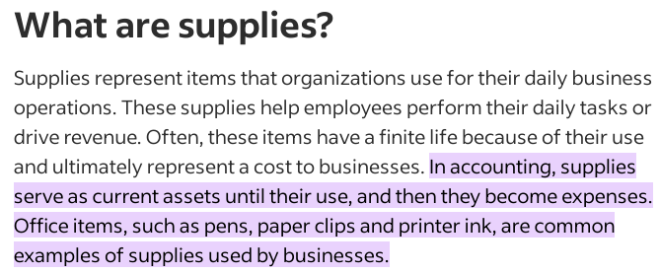
JOURNAL ENTRIES
(1) Supplies purchased for $5,000 from supplier on credit.
Debit: Office Supplies Account 5,000 (A+)
Credit: Payable Account 5,000 (L+)
(2) Returned Supplies back to supplier $2,000.
Debit: Payable 2,000 (L-)
Credit: Office Supplies Account 2,000 (A-)
(3) Supplies consumed during the year $1,000
Debit: Supplies expense 2,000 (E+)
Credit: Office Supplies Account 2,000 (A-)

